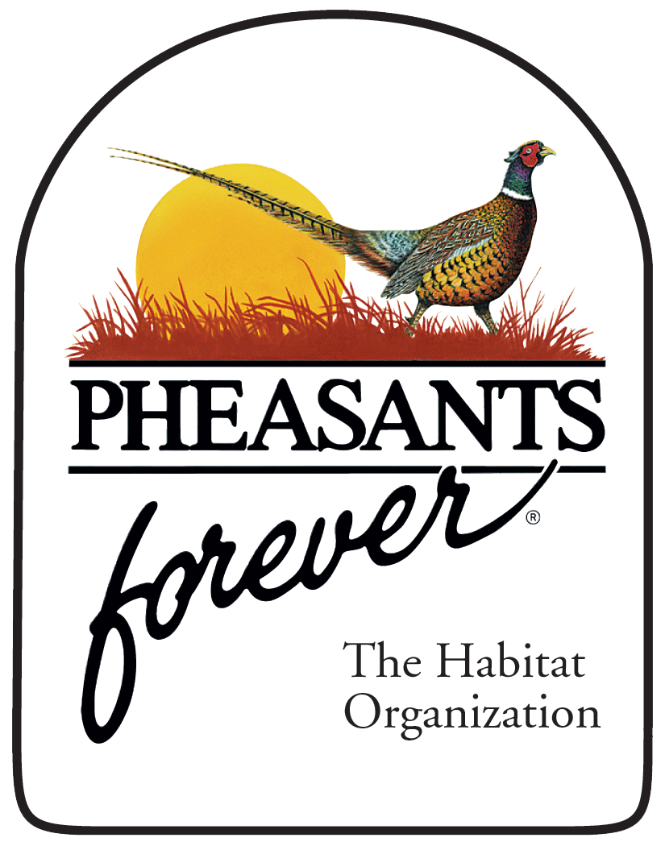
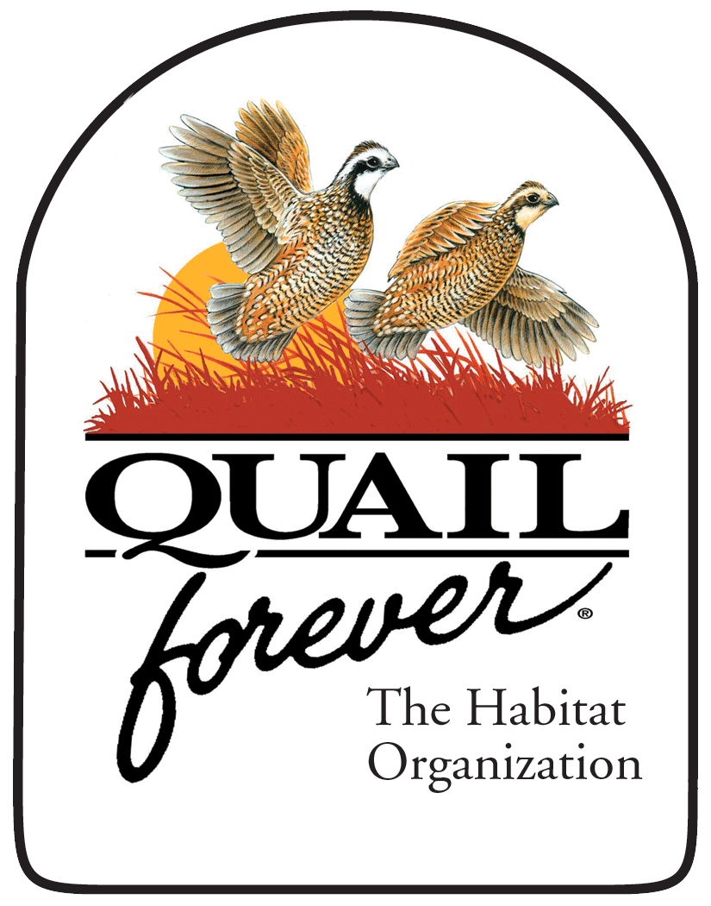
Habitat Cooperator Sign
Chapter Order Form

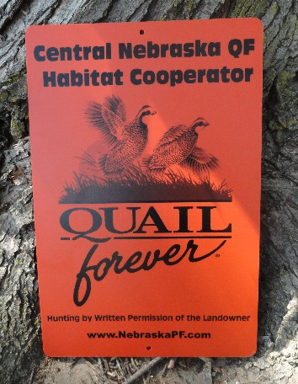
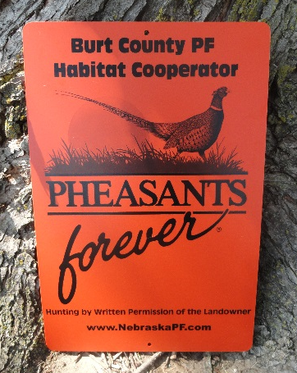
Chapter Name & Number: ________________________________________
Officer Contact: _________________________________________________
Phone Number: __________________________________________________
Email: _________________________________________________________
Shipping Address: ________________________________________________
_________________________________________________________________
Order Quantity (minimum 50 required, increments of 25): _______________
Sign Dimensions:
Material: .125 gauge Polyethelene
Size: 12” x 18”
Colors: Orange Sign, Black Ink
Holes: Two 1/4" diameter
Corners: Radius (rounded)
Other: UV Colorant added to Pigment of ink
Your chapter’s name will be printed on your signs

Chapter Cost = $10.80 per sign plus shipping for 100+ signs
$12.20 plus shipping for less than 100 signs
Your chapter will be invoiced after the signs are shipped.
Submit Order Form To:
Ashley Nelson
asnelson@pheasantsforever.org
If you have any questions please contact your Regional Representative
Colby Kerber 308-520-0876; Jerry McDonald 402-875-3810

