Using Google Maps for Directions to Burn Site

- Go to https://www.google.com/
- Click tile icon in upper Right Hand Corner 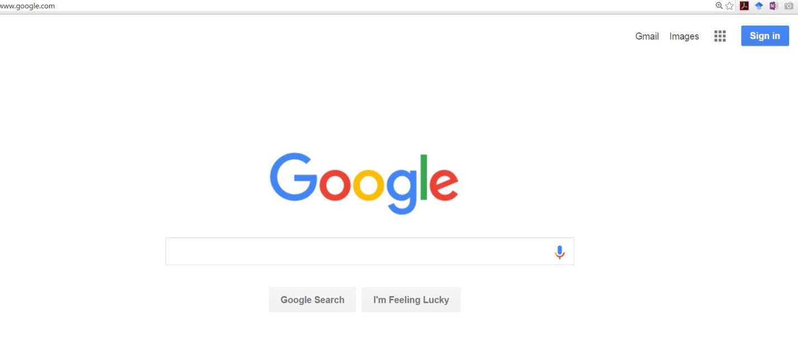
- Select Maps in drop down box
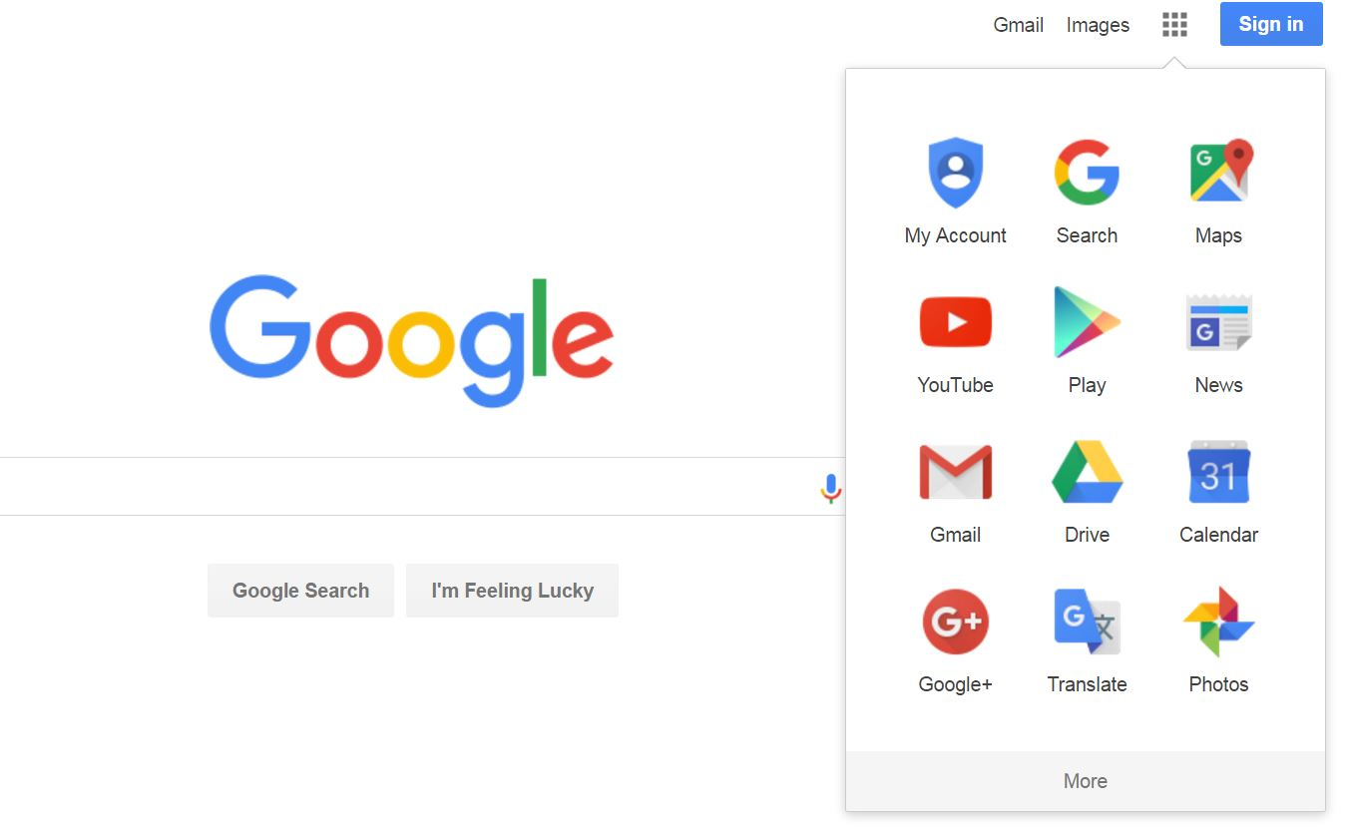

- Type in nearest city or home address you are meeting in search box and hit enter. If the address you typed in leads directly to your staging area at please skip to number 8.

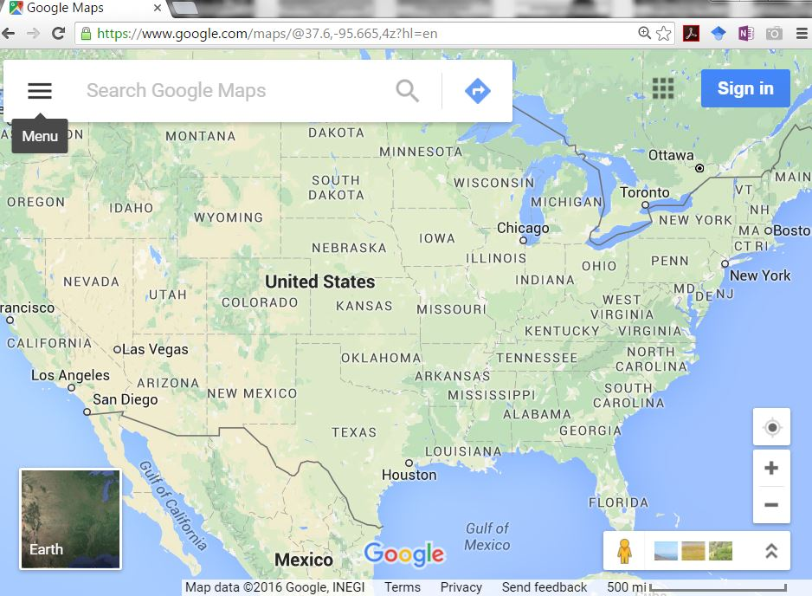
- Click on satellite view to show aerial photo of site or leave as map
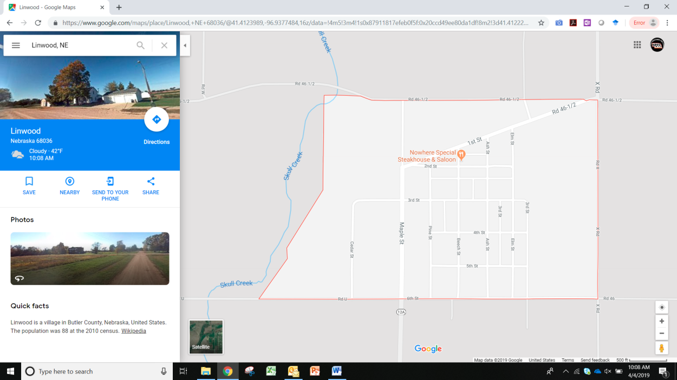

- Click and hold left mouse to drag map up, down, and side to side and use the + sign to zoom in and – sign to zoom out.
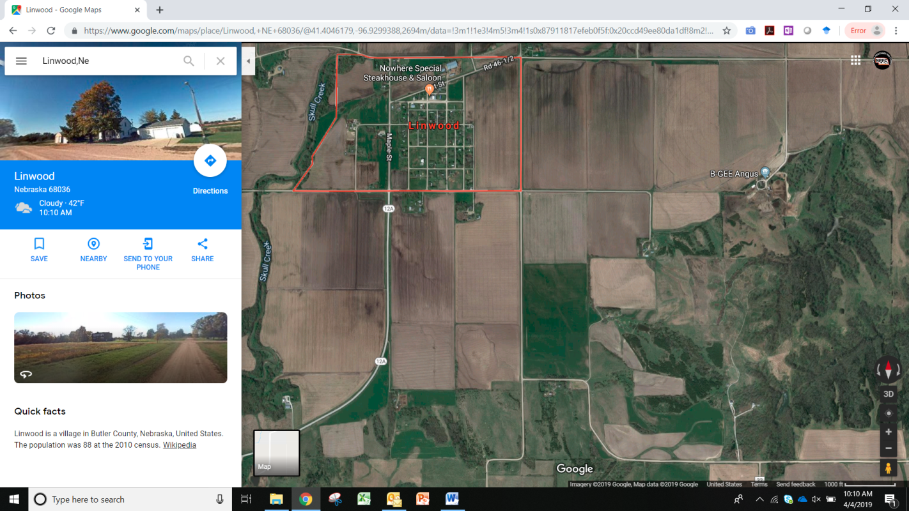
- Once you locate staging area “left click” on the mouse and locate the pop up at the bottom of the map and click on the coordinates (do not click on address or blue turn sign) (The meeting site can be a home address, middle of a section, a specific gate, a windmill, or anywhere you need it)
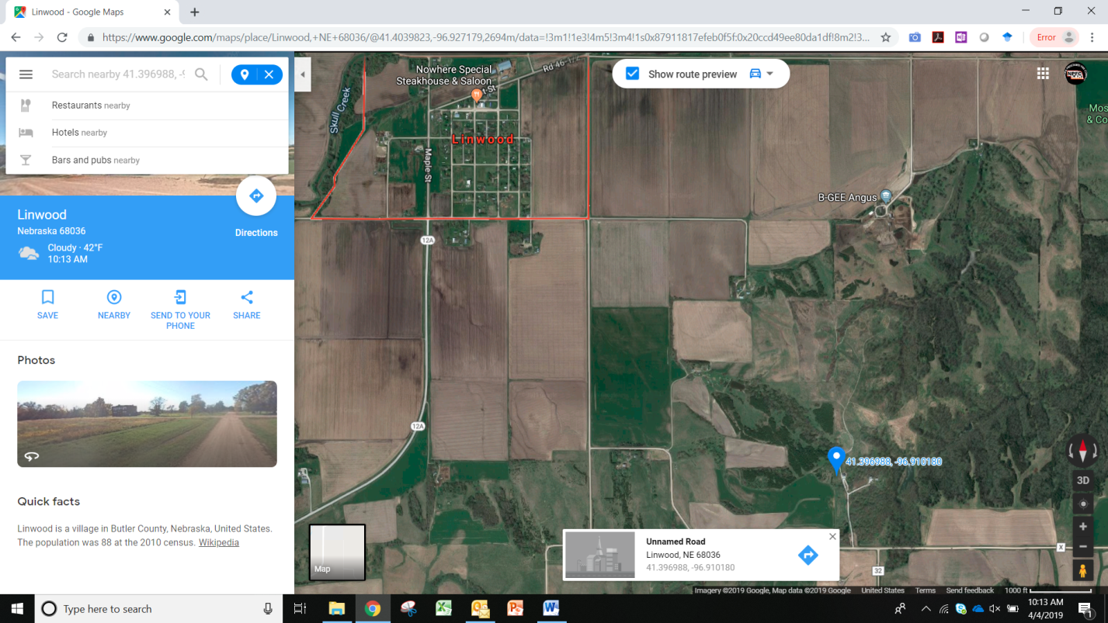

- Click on Share button
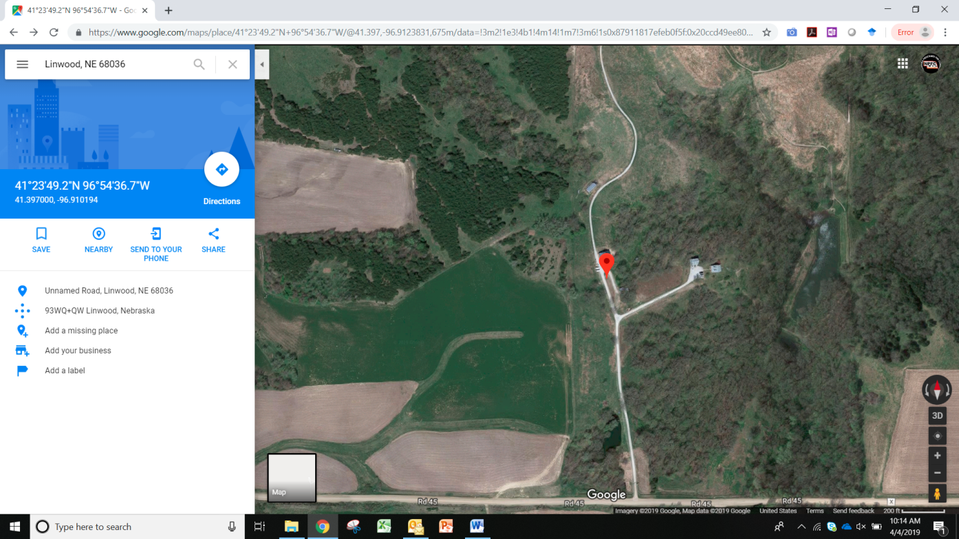
- Dialog box will open up
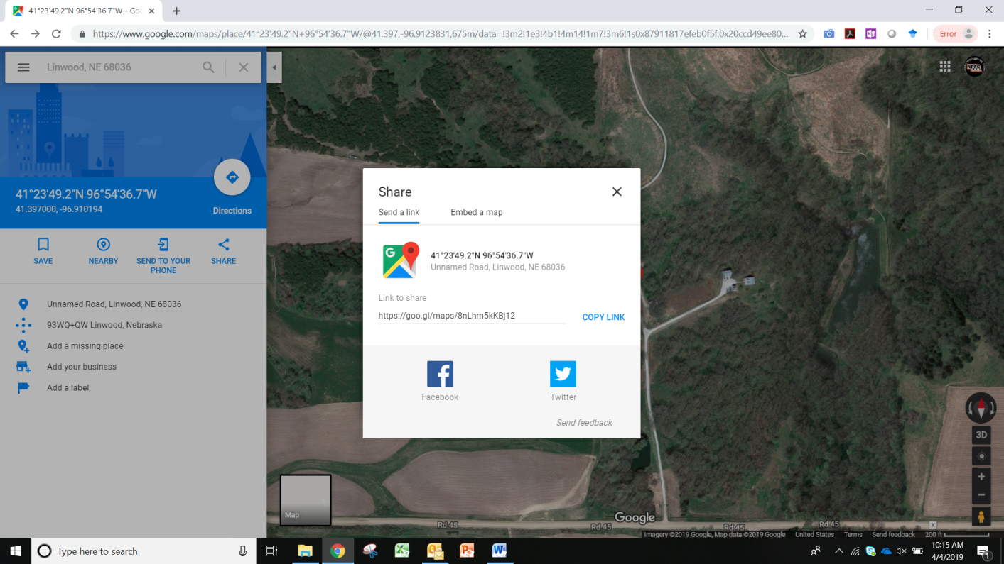
- Click on copy link, then paste into email or you can share via your PBA’s Twitter or Facebook page.

